**Video Player JavaScript Documentation**

### Elements

- **`video`**: The video element in the HTML document. It is controlled by the script to play, pause, adjust volume, etc.

- **`playPauseBtn`**: Button to toggle between play and pause states.

- **`isChecked`**: Checkbox used to check if the video is playing or paused.

- **`volumeUp`**: Button to increase the volume.

- **`volume`**: Slider input to adjust the volume.

- **`volumeDown`**: Button to decrease the volume.

- **`forward`**: Button to skip forward in the video.

- **`backward`**: Button to rewind the video.

- **`timeLine`**: Slider input to scrub through the video.

- **`videoSpeed`**: Dropdown to adjust video playback speed.

- **`loopVideo`**: Checkbox to toggle video looping.

- **`mute`**: Checkbox to mute/unmute the video.

- **`fullScreen`**: Button to enter full-screen mode.

- **`videoCurrentTime`**: Display element showing the current playback time of the video.

- **`videoDuration`**: Display element showing the total duration of the video.

- **`volumeImage`**: Image element to show the volume or mute icon.

- **`videoLable`**: Label element to trigger play/pause functionality.

- **`loopLabel`**: Label element to indicate whether looping is enabled or not.

- **`menu`**: Button to toggle the visibility of the menu.

- **`menuDiv`**: Container for the menu items.

### Functions

#### `togglePlayPause()`

Toggles the play/pause state of the video. Updates the background image of `playPauseBtn` based on the current state of the video (playing or paused).

#### `toggleVolumeImage()`

Updates the `volumeImage` icon based on the current volume of the video. Changes the icon to indicate whether the video is muted or not.

#### `increaseVolume()`

Increases the video volume by 0.1 (capped at 1). Updates the volume slider and icon accordingly.

#### `decreaseVolume()`

Decreases the video volume by 0.1 (capped at 0). Updates the volume slider and icon accordingly.

#### `toggleMute()`

Toggles the mute state of the video. Updates the `volumeImage` icon based on whether the video is muted or not.

#### `toggleLoop()`

Toggles the loop state of the video. Updates the background color of `loopLabel` to indicate whether looping is enabled.

#### `formatTime(seconds)`

Formats a given time in seconds into a `MM:SS` format.

#### `updateTime()`

Updates the `videoCurrentTime` and `videoDuration` display elements with the current playback time and total duration of the video.

#### `updateSlider(slider)`

Updates the visual appearance of the given slider based on its current value. Changes the background gradient to reflect the slider's value.

#### `move(direction)`

Moves the video playback by 10 seconds in the specified direction (`'forward'` or `'backward'`).

### Event Listeners

- **`videoLable` Click Event**: Toggles play/pause state of the video.

- **`playPauseBtn` Click Event**: Toggles play/pause state of the video.

- **`fullScreen` Click Event**: Enters full-screen mode for the video.

- **`volume` Input Event**: Adjusts video volume based on slider input and updates the slider visual.

- **`mute` Change Event**: Toggles mute state of the video and updates the icon.

- **`volumeUp` Click Event**: Increases the video volume.

- **`volumeDown` Click Event**: Decreases the video volume.

- **`loopVideo` Change Event**: Toggles loop state of the video and updates the loop indicator.

- **`videoSpeed` Change Event**: Adjusts the playback speed of the video.

- **`video` Timeupdate Event**: Updates the time display, slider position, and slider appearance based on current video time.

- **`timeLine` Input Event**: Scrubs through the video based on the slider input.

- **`backward` Click Event**: Rewinds the video by 10 seconds.

- **`forward` Click Event**: Skips forward in the video by 10 seconds.

- **`menu` Click Event**: Toggles the visibility of the menu.

### Additional Notes

- **Volume Range**: Volume is adjusted between 0 and 1, with steps of 0.1.

- **Full Screen**: Uses the Fullscreen API to enter full-screen mode.

- **Looping**: Changes the loop state of the video and visually indicates looping status.

**Presentation:**

**Video Player JavaScript Code**

1. Introduction

Objective: Provide an overview of the JavaScript functionality for a custom video player.

Features: Play/Pause, Volume Control, Mute, Full-Screen, Looping, Playback Speed, Time Scrubbing, etc.

2. Key Components

HTML Elements:

Video Player Element

Control Buttons (Play/Pause, Volume, Full-Screen, etc.)

Display Elements (Current Time, Duration)

Sliders (Volume, Time Line)

Menu

3. Core Functions

Toggle Play/Pause

Description: Toggles between playing and pausing the video.

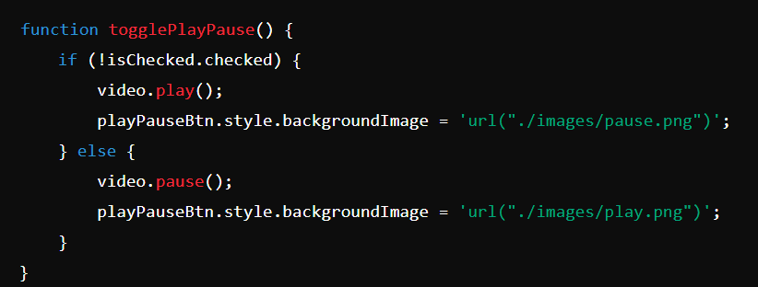Implementation:

Volume Control

Description: Adjusts volume levels and updates volume icon.

Increase Volume:

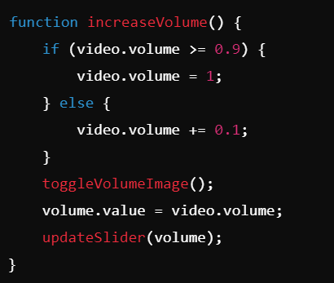

Decrease Volume:

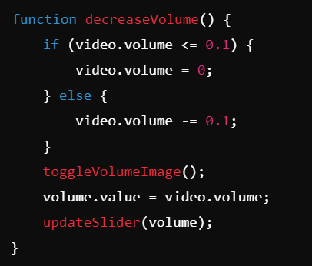

Mute Toggle

Description: Mutes or unmutes the video and updates the icon.

Implementation:

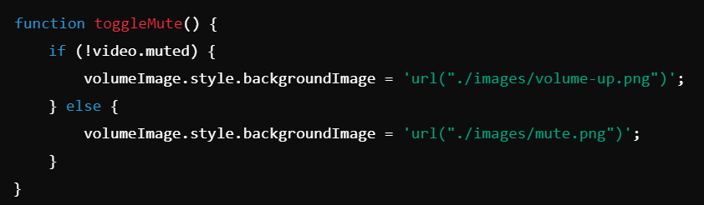

Looping

Description: Toggles video looping and updates the loop indicator.

Implementation:

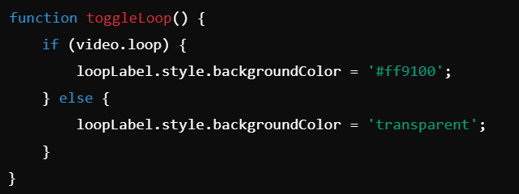

Playback Speed

Description: Adjusts video playback speed.

Implementation:

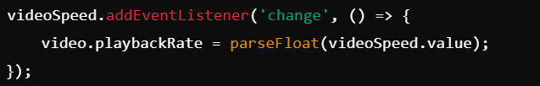

Time Scrubbing

Description: Allows user to scrub through the video using a slider.

Implementation:

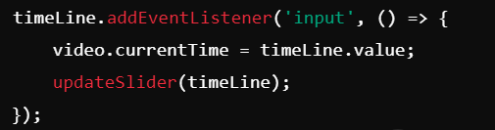

4. Event Listeners

Play/Pause Button:

Toggles video playback and updates the button icon.

Volume Controls:

Adjusts volume and updates the icon.

Mute Toggle:

Mutes or unmutes the video and updates the icon.

Full-Screen Button:

Enters full-screen mode.

Loop Toggle:

Enables or disables looping.

Playback Speed:

Changes the playback rate.

Time Line Slider:

Updates the video playback time.

5. User Interface

Volume Control Slider

Play/Pause Button

Full-Screen Toggle

Mute Button

Loop Toggle

Playback Speed Dropdown

Time Line Scrubber

Current Time and Duration Display

6. Conclusion

Summary: Recap of the functionality and features of the custom video player.